PENNYRILE FAITH RIDERS

FALL/WINTER EVENTS – 2017

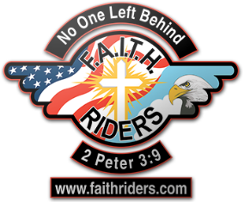

- SEPTEMBER 16 – FELLOWSHIP RIDE – Jefferson Davis Memorial, Hopkinsville, KY

- SEPTEMBER 21 – MEETING/DINNER – ROCKHOUSE PIZZA

- OCTOBER 21 – FELLOWSHIP RIDE – RIDE DESTINATION TBD (will be posted on our Facebook page)

- NOVEMBER 16 – MEETING/DINNER – PLACE TBD

- DECEMBER 14 OR 21 – CHRISTMAS PARTY – PLACE TBD –WATCH FOR DETAILS

(For more info, see our Facebook page or call Mark Odum at 812-899-0189)

